Reading maps

This activity aims to enable a worker to gain some familiarisation with using Google maps to identify a route to travel from one location to the next. This activity is designed for the learner to work with a more experienced map-reader who is familiar with Google maps, to guide the learning process.

Who is this activity aimed at?

This activity will provide workers with practise at using Google maps. At the end of the activity, the worker will have gained some basic knowledge and practise in using Google maps to identify routes from one location to the next. It will also provide practise in both using a digital device.

Outcome:
Google maps are a readily available free tool that can be used to assist navigation from one location to another. This activity will enable you to work with a more experienced person in map reading and Google maps, to gain a basic knowledge of Google maps and its use in planning routes.

Preparation:
An experienced map-reader and knowledgeable person in the use of Google maps eg. supervisor, will work with a learner to undertake the activity below. A discussion on how Google maps can be used in your workplace would assist the learner. Some workplace examples may be demonstrated to assist in this process.

What will you need?
You will need access to a digital device with Google maps. A quiet location to work through the exercises. A series of workplace locations would add to this exercise.

Activity
Follow the instructions below to explore ‘Google Maps’.
- Go to www.google.com.au/maps
- Type your current address into the box at the top left hand corner of page (make sure you type in the full address) and press enter. What happens?

- Experiment with the buttons at the bottom right hand corner of the screen. What do each of them do?
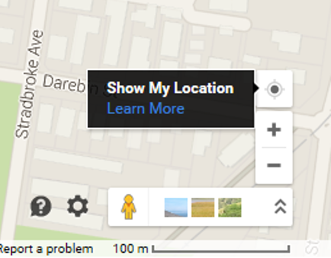

- Select the ‘direction’ arrow in the top left corner and type in a location that you would like to go to. What happens?
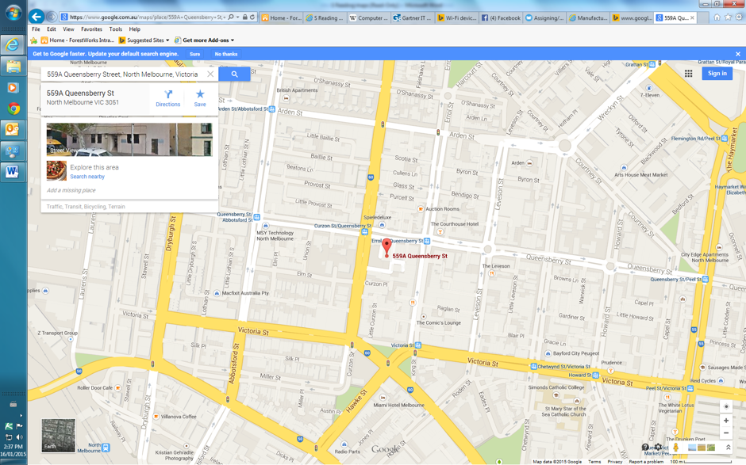

- Using Google maps identify the route from your current location to the closest bank. How far is it and how long would it take to drive there?

- The route from your home to a local supermarket. How far is it and how long would it take to drive? How long to walk?

- The route from your workplace, to a hospital. How far is it and how long would it take to drive there?

- Give a colleague detailed, verbal instructions on how to drive to the nearest airport.

- On google maps, plan a route from your home to an address of a family member or friend. Once you have planned and mapped the route, print out the map and the detailed driving directions

